**Web DEVELOPMENT**

* MERN (MongoDB, ExpressJS, ReactJS, NodeJS)
* LAMP (Linux, Apache, MySQL, PHP)
* MEAN (MongoDB, ExpressJS, AngularJS, NodeJS)

**MERN Stack - An Overview**

Although there are many different stacks out there to consider, some have become more common than others due to their popularity and ease of use. One of these popular stacks is the MERN stack. Let us check out MERN stack full form which consists of the following technologies:

1. **M** stands for **MongoDB ( Database )**which is a Popular NoSQL (Non-Structured ‘
2. Query Language) Database System.
3. **E** stands for **Express,** A powerful middleware that sits on top of the server side Node.js web APIs.
4. **R** stands for **React,** a client-side JavaScript Library renowned for developing rich user experiences.
5. **N** stands for **Node js,** A premier JavaScript web server development environment that is fast and efficient.

It makes the advancement interaction smoother and simpler between the backend and the frontend as both use JavaScript as the primary technology.

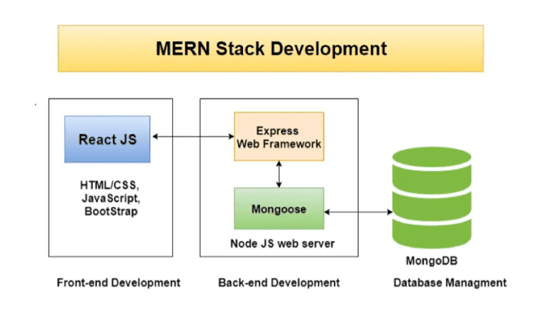

Every one of the four technologies gives a start-to-finish design for the developers to work, as every one of these technologies has a major impact on the improvement of applications.

To mention some of the Impacts of the MERN stack on the overall web app are as follows:

1. **Cost-effective:** All the four technologies mentioned above are Open source, and the frontend and the backend are built on JavaScript making MERN stack cost-effective. With lesser investment users get better results.
2. **SEO friendly:** Websites created using MERN technologies are always SEO friendly. Here, SEO (Search Engine Optimization) friendly means that search engines like Google, Yahoo, etc., can search each page on the website efficiently and effortlessly.
3. **Better performance:** Due to the fast exchange of response between backend, front-end, and database, which ultimately improves the website speed yielding better performance, thus providing a smooth user experience.
4. **Improves Security:** Here security refers to web application security of various technologies, processes and methods used for protecting web servers and various web applications and APIs (Application user interface).
5. **Provide the fastest delivery:** Web and mobile applications built using MERN Stack are made much faster, which means they can be delivered faster to our clients.
6. **Provides faster Modifications:** These technologies support quick modifications to clients' requests and are agile.
7. **Open Source:** The four technologies involved in MERN Full Stack are open-source. This solid feature allows for the better community and development support that developers get, which makes development faster and more efficient.
8. **Easy to switch between**[**client and server**](https://www.knowledgehut.com/blog/devops/chef-architecture)**:** MERN is remarkably simple and prompt because it's written in only one language. Therefore, it is easier to switch between client and server.

**MERN Stack Components**

Now you know that there are four components to the MERN Stack, so let's dive in to understand how each one fits in.

MERN adheres to a 3-tier architecture system consisting of 3 layers

These layers are as follows:

1. Front-end tier for Web
2. The middle tier is Server
3. Backend tier as Database

Let's understand these tiers before we jump into the components, so to make it easier to understand every technology's role in the stack..

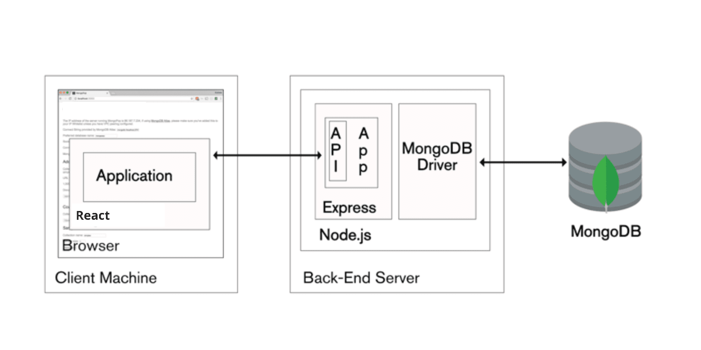

**1. Web or front-end tier –**Basically, the top tier of the MERN stack handled by React.js, which is prominently used open-source front-end JavaScript library for building Web applications. It is renowned for creating dynamic client-side applications and is often used to construct complex interfaces. One of its best features is that it allows the reusability of code which has many benefits and is a time saver.

**2. Server or middle-tier -** The next level from top layer is handled by two components of the stack, i.e., Express.js and Node.js. They handle it simultaneously where Express.js maintains the server-side framework and middleware, running inside the Node.js server. This empowers developers to spin up dynamic APIs and web servers at the same time adding helpful functionalities to Node.js. Whereas on the other hand, Node.js, being a cross-platform runtime environment for executing JavaScript code outside a browser, holds a very important role in itself.

**3. Database as backend tier -** Being one of the most important levels of the MERN Stack, it is handled by MongoDB. The main role of a database is to store all your application-related data. It maintains a proper record and generates multiple replica files of the data whenever the system fails. It can retrieve the exact information or data that the user wants. It is the most popular NoSQL database.

Let's dive in to understand one by one the four Major components that play a major role in forming MERN Stack:

**MONGODB**

1. Mongo DB is a popular NoSQL and open-source document-oriented database.
2. 'NoSQL' is a non-relational database and does not require a fixed schema, therefore it stores the data in a different format unlike the relational tables.
3. The format in which the data is stored is known as BSON (Binary JavaScript Object Notation)
4. Its structure encodes the length and type of information and therefore allows it to be parsed much more quickly, also allowing a highly scalable and flexible document structure.
5. It is faster than RDBMS as it has efficient storage and better indexing techniques.
6. MongoDB uses JavaScript as a coding language which in itself is a big advantage for this stack.
7. As it is Schemaless, data stored is stored in a separate document.
8. It supports a flexible document model, which is remarkably fast for any developer to create.
9. MongoDB can easily scale by adding more and more servers, and at the same time it increases productivity with its flexible document model.

**EXPRESS**

1. Express is a JavaScript-based server-side framework runs within Node js.
2. Being among the best [**backend development**](https://www.knowledgehut.com/blog/web-development/how-to-become-backend-developer)frameworks, it empowers the developer with a platform to create and maintain robust servers.
3. It is mostly used for building and designing web as well as mobile applications easily and efficiently.
4. It allows developers to spin up robust APIs and web servers with much ease and simplicity.
5. Express adds robust and efficient functionalities to the system with routing and middleware that make it easy to connect with Databases like MongoDB and handle errors using error handling middleware.
6. Express with its gigantic suite of third-party add-ons provides better functionality, helps to increase the security level, and improves the speed of the software.
7. Also, With its built-in router, it promotes code reusability.

**REACT**

1. React is a very popular open-source JavaScript library used for building Web applications, specifically used to build user interfaces for a single-page web application.
2. Another thing to note is that it is not a JavaScript framework but a JavaScript library developed by Facebook.
3. It allows us to create reusable UI ( User Interface ) components that are very fast, simple, and scalable.
4. React can also be used with a combination of other JavaScript libraries or frameworks.
5. It has very fast performance due to the immutability of data.

**NODEJS**

1. Node js is also an open-source environment for the server side, it is a cross-platform runtime environment that helps execute JavaScript code outside the browser.
2. To keep it clear it is not a programming language or a framework.
3. It is used time and again for building and developing numerous backend services on the web and mobile.
4. It is incredibly consistent and provides extremely robust and quick service.
5. It plays a key role in building real-time web apps because of its faster synchronization.
6. It has a Non-blocking/Asynchronous nature due to the event loop and therefore acts like a fast suite where all the operations are performed quickly.
7. It also provides caching properties where a single module can be easily cached so you do not need to re-execute the same lines of code and thus quickening the response time.